

|  |
| --- |
| LIBRARY  MANAGEMENT  SYSTEM |
|  |
| June 21  COMPANY NAME  Authored by: Your Name |



|  |
| --- |
| INDEX   1. Search Student/Faculty details  * Adding a Student/Faculty * Removing a student/faculty * Edit Student Details  1. Issuing a Book 2. Returning a Book 3. Admin Functionalities  * Adding a new book * Add new Books Id’s * Remove Book * Available Books |
| Searching the Student/Faculty: |

1. To search for the student, we must search with the roll number of that Student.
2. The Roll number is divided into 3 tabs to make convenient to user.

* Year : The field should be filled with passing out year. The length of numbers is restricted to 2. So, you must give the last 2 digit of a year. Ex : 23, if the year is 2023.
* Select the course : The course can be selected from the list provided. If we are about to search for a faculty member, then we must select faculty. Otherwise, we must select the course accordingly.
* RollNo : The field should be filled out with atleast 3 digits of last 3 digits of Roll number.

1. After filling the Roll number, we must click on the search button to get the student/faculty details like this.

1. To search for the faculty, we must choosefaculty from the dropdown list. Then, enter the CE ID of the faculty in the field provided for ID and click on search.

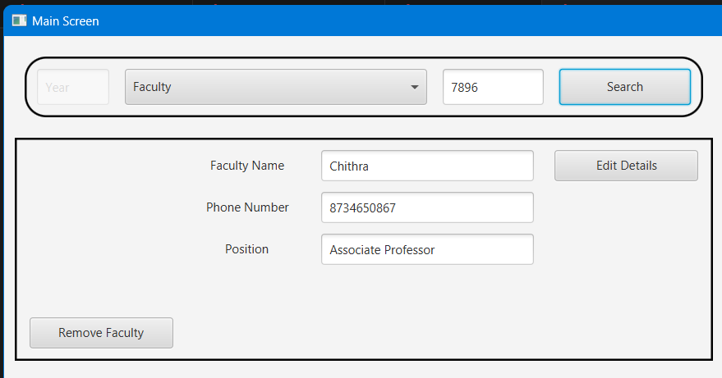

Adding a Student/Faculty:

* After entering the details and clicking on search button, If you see a dialog box displaying that no details found of such student/faculty, then click on ‘OK’ button to proceed for adding the details.

* After clicking on ‘OK’, you will see blank fields to enter the name and phone number of the student/faculty and then click on ‘Save Data’ button to save the entry.

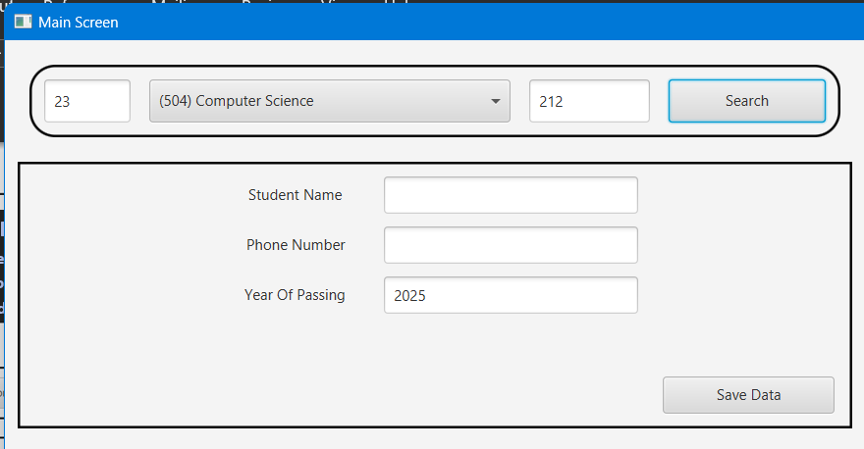

Removing a student/faculty

* To remove a Student/Faculty, all the books taken should be returned. That is, the table displaying the books taken should be displaying ‘No books taken’.

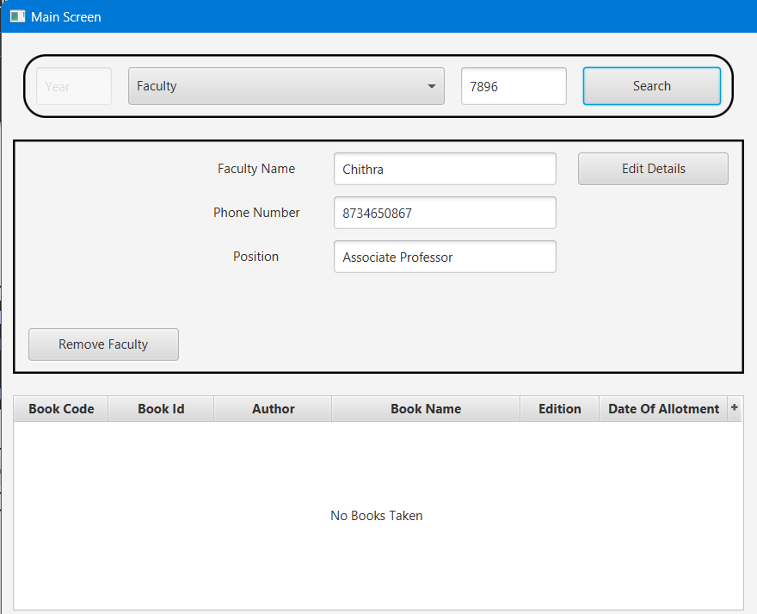

* If the student/faculty returned all the books, we can remove the student/faculty by clicking on the “Remove Student” button and should click on ‘Yes’. Otherwise, ‘No’.A screenshot of a computer

  Description automatically generated

Edit Student/Faculty Details

1. To edit the student/faculty details, we have to click on the Edit details button, and can move on to the Name, Phone number and Year of passing fields and can edit.
2. After editing, if we click on ‘Save Data’, we will get a dialog box displaying the updated details of student and asking for confirmation to click on ‘OK’ to save.

1. If you want the details to be unchanged or you have updated wrong details, then close the dialog box.

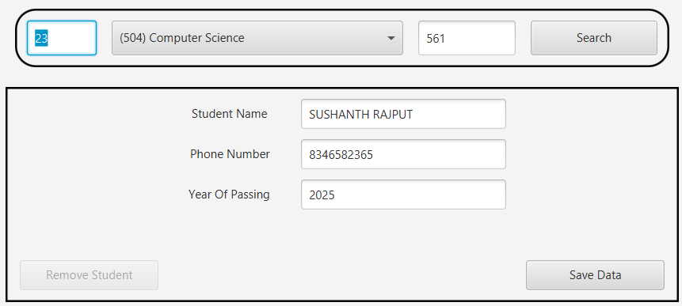

Issuing a Book

1. If a student comes to borrow a book and we must save the detail, then we must click on the ‘Issue New book’.
2. Then a new window opens to save the details book.
3. The ‘Roll number’ will be displaying already for which student/faculty we shall issue the book.
4. The ‘Book Id’ can be known from the book which is being taken.
5. After entering the book id, click on ‘Add’ button to add the corresponding book to table.
6. In this way, we can add multiple books to the table to issue them to the student/faculty.
7. Then after, we click on the ‘Issue Book’.

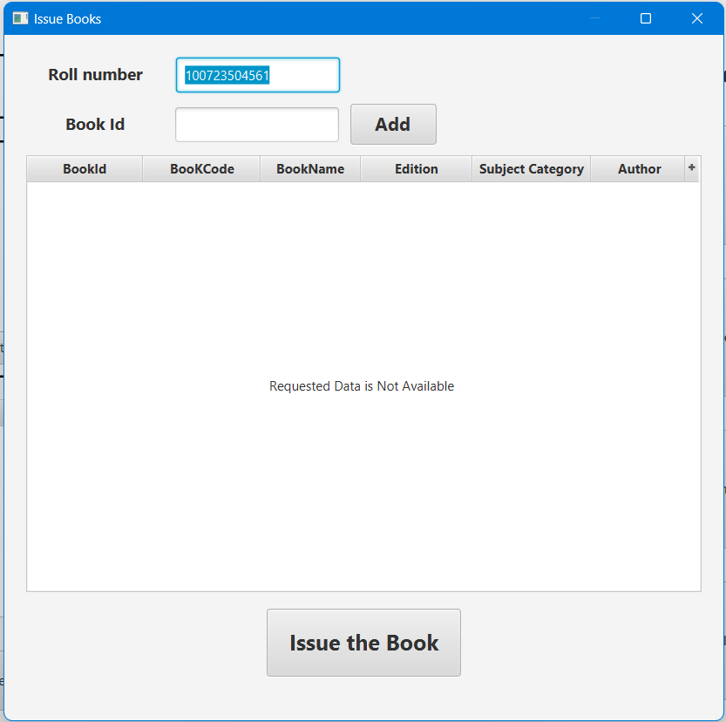

Returning a Book

* To return a book, you have to just select any of the book being displayed in the table and click on ‘Return the Book’ button.

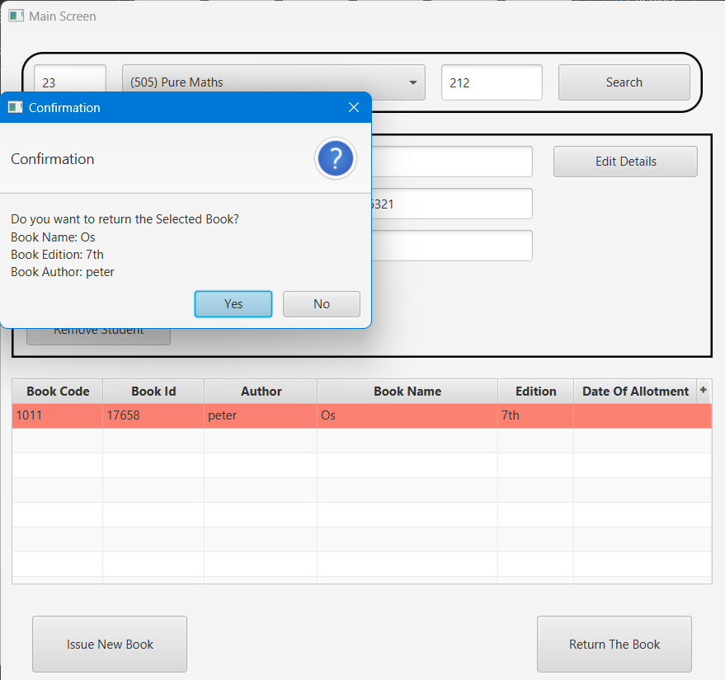

* By clicking on ‘Yes’, the book will be returned. Otherwise, click on ‘No’ to let it be borrowed.

Admin Functionalities

1. Add New Book

* This option is to add new book details into the database.

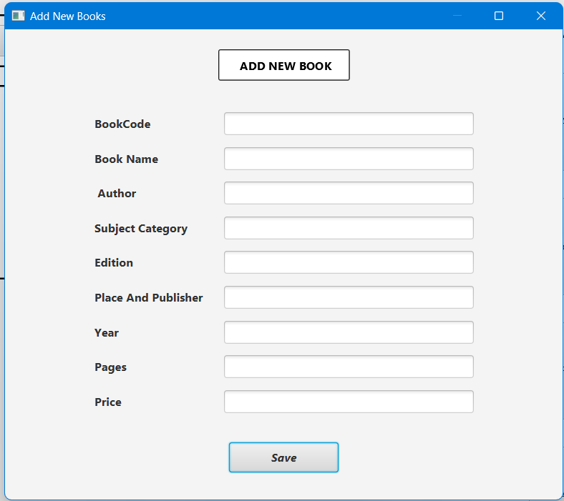

* *Book Code : It is the code given based on the subject category.*
* *Book Name: It is the book title.*
* *Author : It is the name(s) of the Author(s) of the Book.*
* *Subject Category : It is the subject of the topic of Book.*
* *Edition : It is the edition has to be given in numbers.*
* *Place and Publisher : It is the place and publisher name.*
* *Year : It is the published year.*
* *Pages : It is the number of Pages.*
* *Price : It is the price of the Book.*
* After entering all the details, click on ‘Save button’ to Save the Book Details.

1. Add New Book Id’s

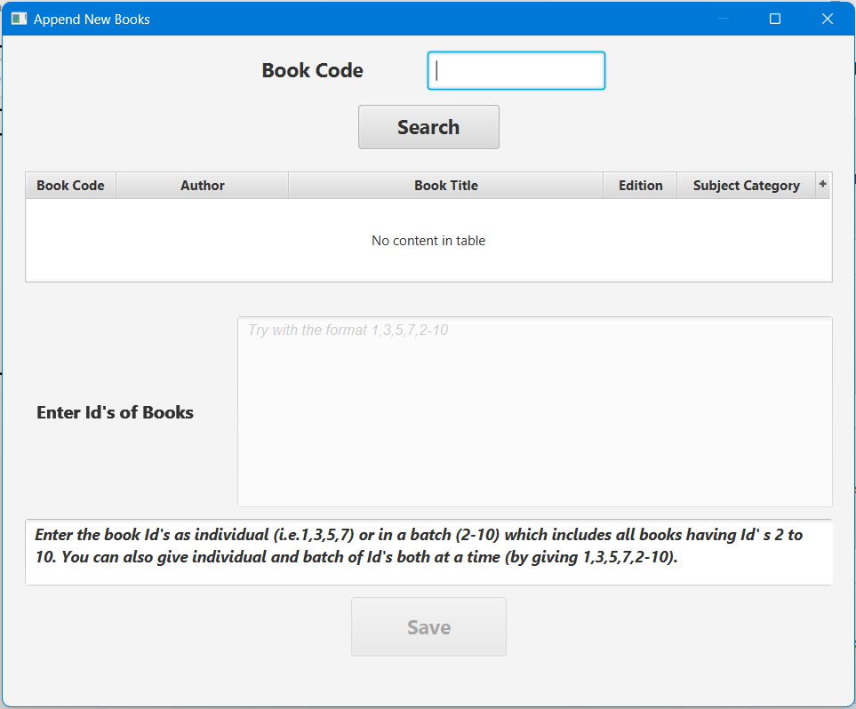

* In this window, we can add books using the saved Book Details which was done by the option ‘Add new Book’.
* *Book Code : Enter the Book Code for which you want to add Books.*
* After entering the Book Code, click on ‘Search’ button to see the book details in the table.
* Enter Id’s of books : In this textbox, you have to enter the book id which is unique to each book in the library unlike the Book code which is common to a group of books.
* We can add single or multiple books at a time by giving Id’s seperated
  + - * 1. *By commas : for example (1,3,5,7) are group of books Id’s seperated by commas.*
        2. *By _ : for example (11-15) are group of books Id’s seperated by hyphen by which all the Id’s (11,12,13,14,15) between 11 and 15 are added at a time.*
        3. *By commas and _ : for example (1,3,5,7,11-15) by which we can add both ways we did in (a) , (b).*

We can give Id’s in either of 3 ways.

* After giving Id’s we have to click on ’Save’ button to add those in database.
* Note that, we must not give the Id which is already given earlier.
* After clicking on ‘Save’ button, a dialog box will be displayed asking for confirmation.
* Click on ‘Yes’ to proceed, or ‘No’ to stop the process.

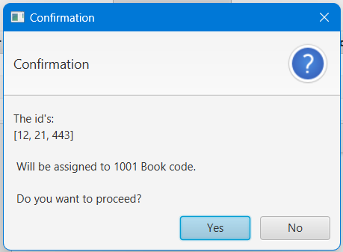

1. Remove Book

* This window is to be used when we have to remove a book when it is torn or kept aside not to use in library.
* We can remove a single Book or multiple books

1. by selecting ‘Book Id’ radio button and entering the Book Id.
2. By selecting 'Book Code’ radio button and entering the Book code.

* After entering the Book Id/Book code, we have to click on ‘Search’ button by which we can see the book details in the below table.
* After we acknowledge that we got what we are searching for by seeing in the table, we can click on ‘Remove’ button to Remove the Book.

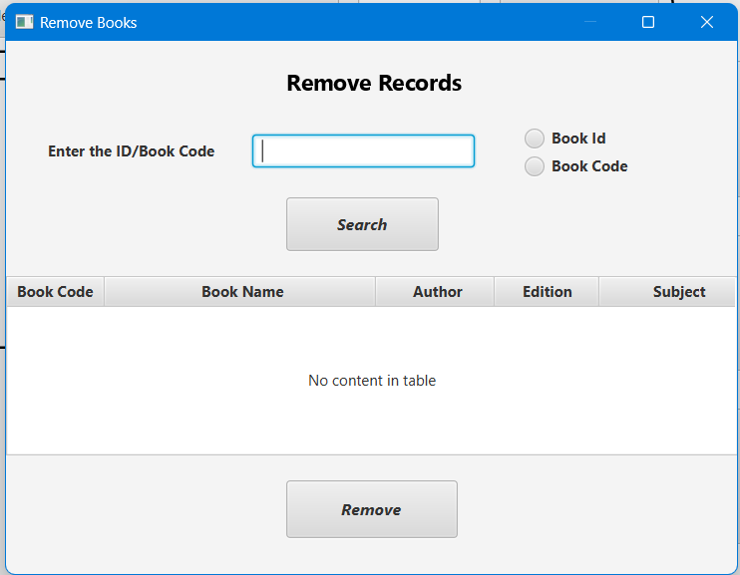

1. Available Books :

* This window is to used when we want to check the availability of books.
* We can enter any Book code or Book Title or any other book detail

1. To check the available number of books and borrowed books.

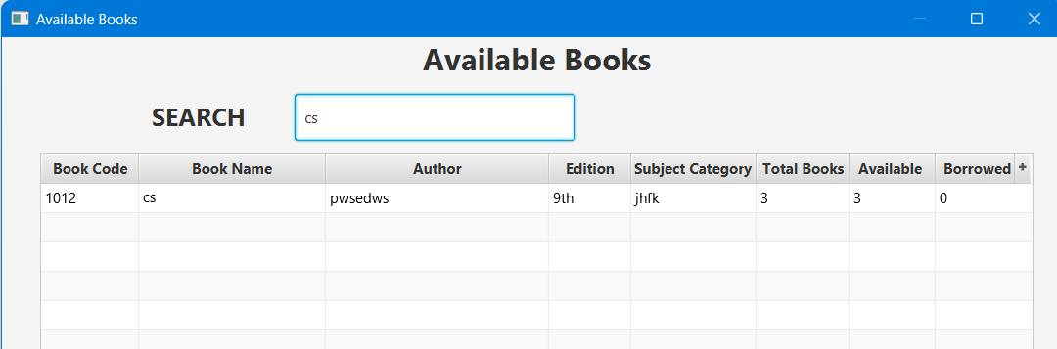

1. To check which Book was borrowed by which Student/faculty.

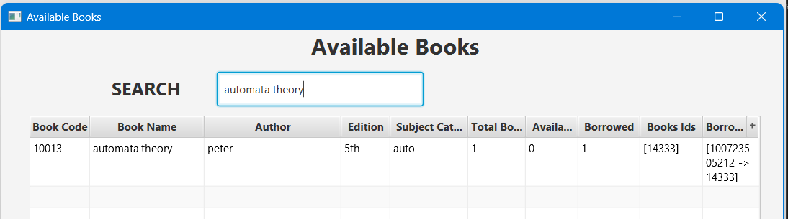

1. This will be helpful when we use the Add New Book Id’s window.
2. To fill in Book code textbox, we may have to check which Book was given which Book code.
3. To check the which Id’s are already added in the database.

Note:

* In every part of this application, for each table you see there will be a ‘+’ symbol at top right end of the table.

* By clicking on that symbol, we can see additional columns which can displayed by selecting. For example, in this table, we click on ‘borrowed by’ column to add that column.

* Or selecting again on the column names with tick symbol, the columns will get hidden. For example, in this table, we click on ‘Author’ column to remove that column.

